**ECEN 248 - Lab Report**

**Lab Number: 2**

**Lab Title: Logic Minimization with Karnuagh Maps**

**Section Number: 519**

**Student’s Name:** [Alex Allahar](mailto:alex.allahar@tamu.edu)

**Student’s UIN: 928009686**

**Date: 09/20/23**

**TA: Yi Deng**

**Objectives:**

The purpose of this lab is to build on the gates used in lab 1 to create a circuit with a real-world application. To understand the logic behind the circuits for the multiple inputs and outputs, the use of karnaughs maps with minimize the logic instead of using truth tables.

**Design:**

The first part of the circuit to designed in the profit calculator. Connect the 5V power supply and ground to the breadboard. Connect 4 rows to the blue strip of the breadboard. Each of the rows will be an input(I, C, S, or H). Use the following gates to create the logic: NOT, AND, XOR, and OR. Follow the circuit diagram shown in the lab 2 slide to connect the correct input to the gates to create the profit logic. To check that the logic works at this step connect the final outputs for P2, P1, and P0 to an LED with a jumper wire. Test a few cases to determine if the logic is sound.

**Results:**

| S | I | H | C | P2 | P1 | P0 | Number |
| --- | --- | --- | --- | --- | --- | --- | --- |
| 0 | 0 | 0 | 0 | 0 | 0 | 0 | 0 |
| 0 | 0 | 0 | 1 | 1 | 0 | 0 | 4 |
| 0 | 0 | 1 | 0 | 0 | 1 | 1 | 3 |
| 0 | 0 | 1 | 1 | 1 | 1 | 1 | 7 |
| 0 | 1 | 0 | 0 | 0 | 0 | 1 | 1 |
| 0 | 1 | 0 | 1 | 0 | 1 | 1 | 3 |
| 0 | 1 | 1 | 0 | 0 | 1 | 1 | 3 |
| 0 | 1 | 1 | 1 | X | X | X | 5 |
| 1 | 0 | 0 | 0 | 0 | 1 | 0 | 2 |
| 1 | 0 | 0 | 1 | 1 | 1 | 1 | 7 |
| 1 | 0 | 1 | 0 | 1 | 0 | 1 | 5 |
| 1 | 0 | 1 | 1 | X | X | X | 3 |
| 1 | 1 | 0 | 0 | 0 | 1 | 1 | 3 |
| 1 | 1 | 0 | 1 | X | X | X | 3 |
| 1 | 1 | 1 | 0 | X | X | X | 5 |
| 1 | 1 | 1 | 1 | X | X | X | 7 |

**Figure 1: Digital Inputs and Outputs Table**

**Conclusion:**

In this lab, I built on the circuit practices learned in lab 1 to create a circuit with a real-world application. To understand the logic behind the circuit, k-maps were used. This new way of minimizing a truth table to obtain the logic function will be useful in larger circuits with multiple inputs.

**Post-lab Deliverables:**

1. Figure 1 shows the relationship between the digital inputs and digital outputs. The cells with X are not possible combinations.
2. The values for the additional 5 rows correspond to the outputs of 3 inputs to the profit logic. The reason these values are not important is that Farmer John’s second rule is that no more than 2 animals can be raised at the same time. Thus these profits are not possible.

| S | I | H | C | Output |
| --- | --- | --- | --- | --- |
| 0 | 1 | 1 | 1 | P1, P0 |
| 1 | 0 | 1 | 1 | P2, P0 |
| 1 | 1 | 0 | 1 | P1, P0 |
| 1 | 1 | 1 | 0 | P2, P0 |
| 1 | 1 | 1 | 1 | P2, P1, P0 |

**Figure 2: Digital Output for Extra 5 Rows Table**

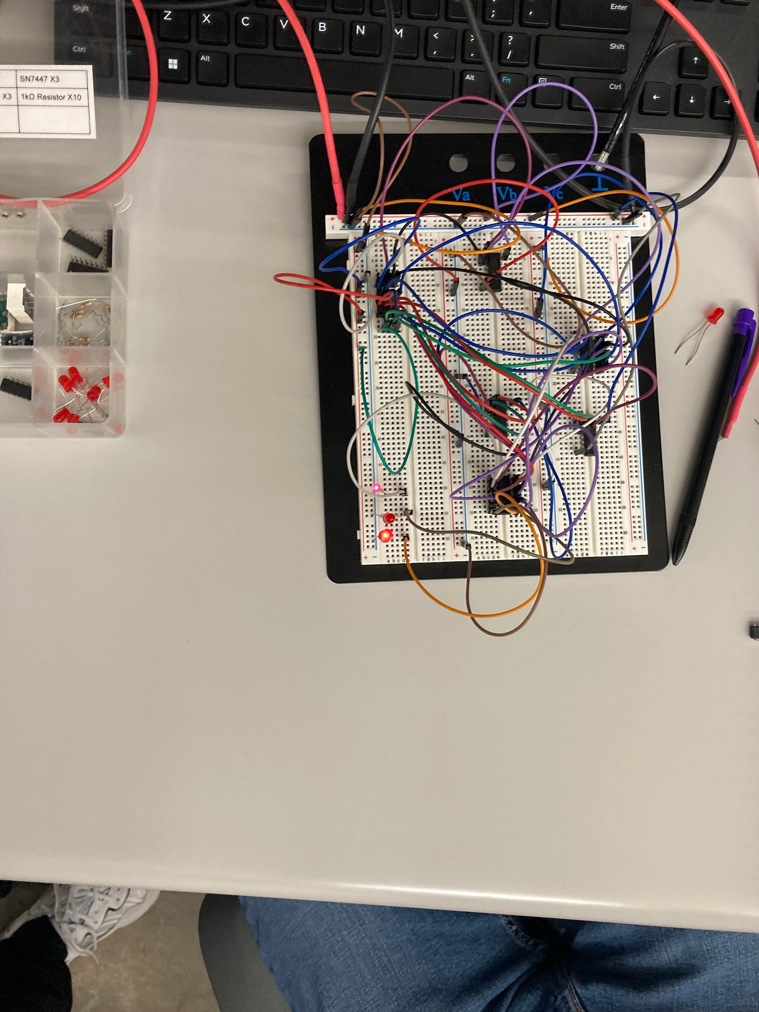

**Figure 3: Image of the Circuit Design when S and H are high, resulting in P2 and P0 being high.**